Cloud Computing
Service delivery model over the internet (cloud). This includes but is not limited to
- Compute power meaning servers such as windows, linux, hosting environments, etc.
- Storage like files and/or databases.
- Networking in azure but also outside when connecting to your company network.
- Analytics services for visualization and telemetry data.

Key concepts
- Scalability is the ability to scale, so allocate and deallocate resources at any time.
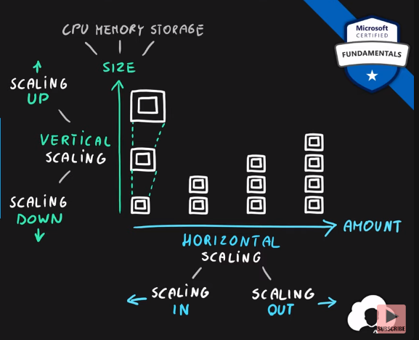
- Elasticity is the ability to scale dynamically.
- Agility is the ability to react fast (scale quickly).
- Fault tolerance is the ability to maintain system uptime while physical and service component failures happen.
- Disaster recovery is the process and design principle that allows a system to recover from natural or human induced disasters, for example by creating two copies of the same application in two different azure regions and setting a DNS routing to auto redirect in case of failures, which costs more to have it by the way.
- High availability is the agreed level of operational uptime for the system. It is a simple calculation of system uptime versus whole lifetime of the system.
$$availability =\frac{uptime}{uptime + downtime}$$
Availability | Year | Month | Day
99% | 3.65 days | 7.31 hours | 14.4 min
99.9% | 8.77 hours | 43.83 min | 1.44 min
99.99% | 52.6 min | 4.38 min | - sec
    - Companies usually aim for 4 nines 99.99% availability.

